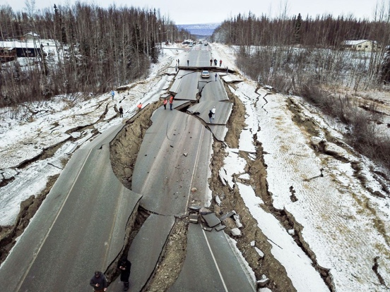
How Can You Graph an Earthquake ?
FINAL ANSWER
NAME:
CLASS PERIOD:

- The region of initiation of seismic energy within the Earth is called the:
  - epicenter,
  - hypocenter,
  - area of greatest building damage
  - area of least building damage

- As rupture along a fault initiates, waves of energy travel outward from the hypocenter in a:
  - linear fashion,
  - a straight-line path,
  - a spherical fashion,
  - none of the above

- The position on the land surface immediately above the hypocenter is the
.

- Body waves emanate spherically from the focus traveling:
  - entirely within the interior of the Earth,
  - along the surface of the Earth,
  - within the worlds oceans
  - into space dude!

- P-waves produce a series of:
  - shearing motions that are at right angles to the direction of wave propagation,
  - contractions and expansions/compressions that are in the direction of wave propagation,
  - circular motions like an ocean wave
  - snake-like motions parallel to the Earth's surface

- S-waves produce a series of:
  - contractions and expansions that are in the direction of wave propagation,
  - snake-like motions parallel to the Earth's surface,
  - circular motions like an ocean wave
  - shearing motions that are at right angles to the direction of wave propagation

- At a seismic station the first waves to arrive are .

- At a seismic station the second waves to arrive are .

- At a seismic station the last waves to arrive are .

- A seismograph is a device used to:
  - sound an alarm,
  - prevent earthquakes from occurring,
  - record the vibrations produced during an earthquake
  - calm the seismologist during an earthquake
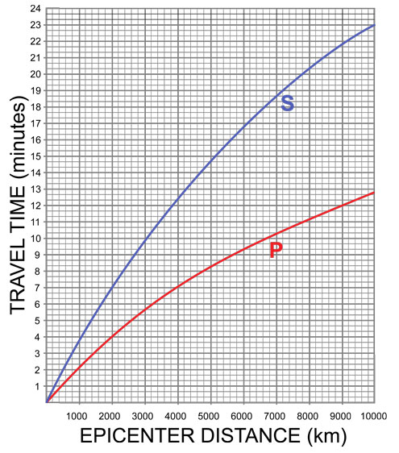
Using the Graph on the Left, answer the following questions:

- How long would it take P-Wave to travel 4000 km?

- How long would it take the S-Wave to travel 1200 km?

- What distance did the P-Wave travel in 7 minutes?

- What distance did the S-Wave travel in 7 minutes?

- If the S-Wave arrived at a Seismic Station at 4:53:20 p.m. and the P-Wave arrived at the same Seismic Station at 4:50:20 p.m. What is the S-P Interval Time or the Lag Time? Show your work.

- Once you’ve calculated the S-P Interval Time/Lag Time for this Seismic Station, determine how far away this station was from the Epicenter of the earthquake.

- From the S-P interval a seismologists can determine the to an earthquake.

- Given three differently located seismic stations, the time-travel graph can be used to determine the position of the .

- Each unit increase in magnitude on the Richter scale corresponds to an increase in seismic wave amplitude of -fold?

- Looking at the Severity Map of the Magna Earthquake that happened recently in Utah, what level of severity did Price experience the Earthquake?

- Looking at the Severity Map of the Magna Earthquake, what level of severity was felt by the fish in the Great Salt Lake?

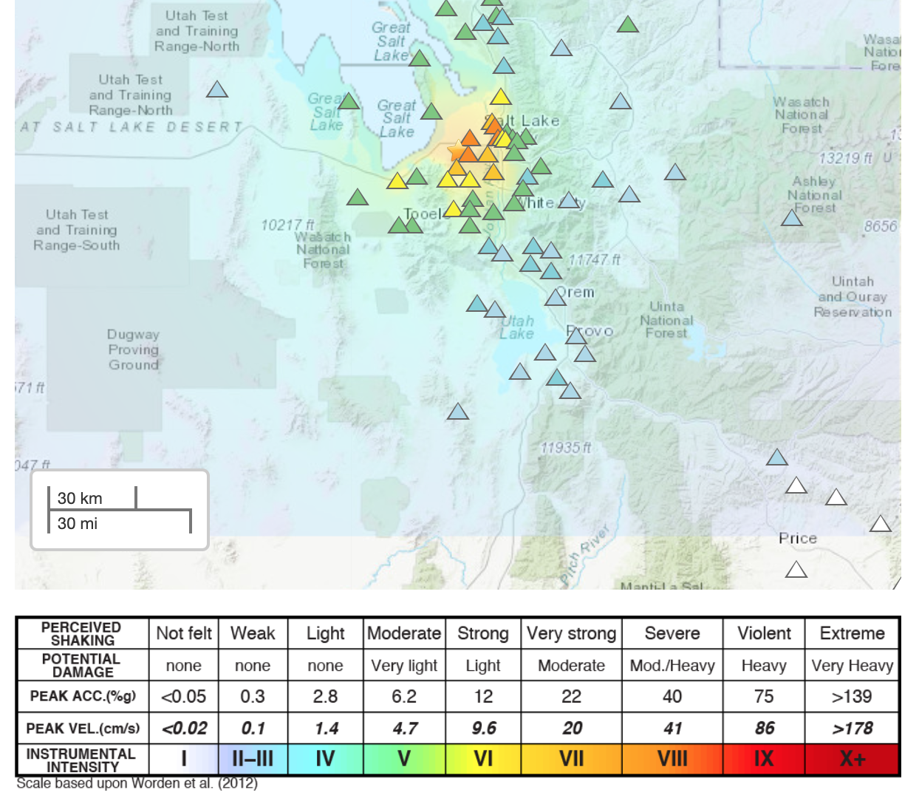

- In the following illustration what do you call location (a) and location (b)? Finish the sentences below.

Location A is

Location B is
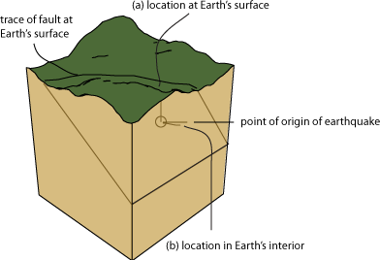

- In the following illustration what is happening at (a) and at (b)? What are the names of the waves that follow the Body Waves? Finish the following sentences:

A is when

B is when

C is when

