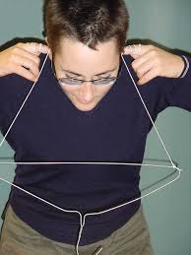
Hanger Sound Lab Activity

Name:
Class Period:

HANGERS AND SOUND WAVES LAB
Student Learning Objective:
Students will experiment with different objects to determine how sound travels through different media

INSTRUCTIONS:
Answer the following questions based on what you think right now. Be open minded to making guesses – IDK is never an answer when doing science.

- What does the word media or medium mean in science? Explain…

- Does sound travel through all objects or media the same? Explain why or why not.

- Follow the instructions on the website to do your lab. Use Dualless to split your screen so you can see both the instructions on the website as well as be able to fill out your data table below

Type of Medium | Description of Sound Created | Loud or Soft Sound | Reason for Sound Outcome

- Did you receive the results you thought you would for each material tested? Explain the differences or similarities between your initial thoughts and your actual outcomes.

- What material had the loudest sound? Explain why.

- What material had the quietest sound? Explain why.

- What would the wave lengths of loudest sound look like - draw an example.

- What would the wave lengths of the quietest sound look like - draw an example.

- Explain what you learned about sound and how it travels from doing this lab.

