National Geographic Ocean Reading and Questions
Our Oceans are Under Attack

Go to: https://www.nationalgeographic.com/environment/habitats/ocean/
Read and answer the following questions

Intro:

- What are the major oceans on Earth?

- How much water do all of the oceans contain?

- What does the ocean absorb?

- What are the effects of this transfer on the Earth?

Sea Life:

- List 5 animals (FROM SMALLEST TO LARGEST) that are in the ocean:

- What does life in the ocean depend on?

- What does the ocean produce?

- At which level is there NO LIGHT in the ocean?

- Read the sentence below:

Despite regular discoveries about the ocean and its denizens, much remains unknown.

What do you think the world denizens means? (Google it if you have to!)

- How much of the ocean is mapped and explored?
- What are the 3 major issues threatening our oceans?
1-
2-
3-

Human Impacts:
- Name 3 human activities that affect the ocean:

- How does each affect the ocean?

- What is climate change?

- What is one of the tools scientists are using to explore the effects of climate change? Follow the link to learn more!

Bizarre Sea Creatures
Choose your favorite organism from the article and describe it using the captions below the image.

Watch this video to help you fill in the Ocean Diagram- Use the video and links below to help label the diagram.
Video: https://utah.pbslearningmedia.org/resource/noaa-interactive-23/the-deep-ocean-ocean-today/
Label the diagram below: Layer of each section
Depth of each section
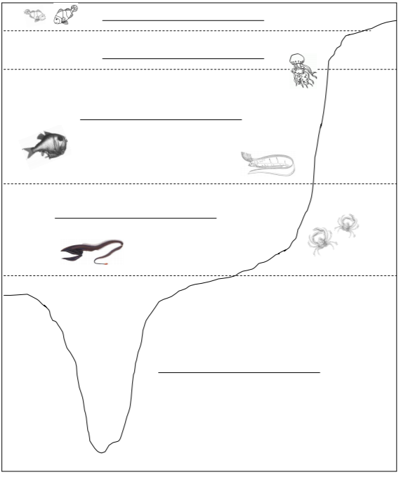

Research links:
Here are some links to use for your research
https://oceanservice.noaa.gov/facts/light_travel.html
https://www.wnct.com/news/ocean-zones-and-what-creatures-live-in-them/
https://nhpbs.org/natureworks/nwep6c.htm
http://discovermagazine.com/galleries/zen-photo/c/creatures-of-the-abyss
https://www.pbs.org/wgbh/nova/abyss/life/bestiary.html
https://www.aquarium.co.za/blog/entry/welcome-to-the-midnight-zone-a-deep-sea-learning-experience
https://www.bbc.com/news/science-environment-17013285

- What are 3 examples of organisms found in the photic zone? Label whether each is a producer, primary consumer, secondary consumer, tertiary consumer!

- What are 3 examples of organisms found in the twilight zone? Label whether each is a producer, primary consumer, secondary consumer, tertiary consumer!

- What are 3 examples of organisms found in the midnight zone? Label whether each is a producer, primary consumer, secondary consumer, tertiary consumer!

- What are 3 examples of organisms found in the abyss? Label whether each is a producer, primary consumer, secondary consumer, tertiary consumer!

- What are 3 examples of organisms found living in trenches? Label whether each is a producer, primary consumer, secondary consumer, tertiary consumer!

