Properties of Snow

Name:

Class Period:

STUDENT LEARNING OBJECTIVE:
- Students will learn about the properties of snow
- Students will learn about how sound travels through snow

INSTRUCTIONS:
- Read through the articles about snow and sound
- Highlight the sentences that contain information about the properties of snow or the properties of sound
- Answer the questions using complete sentences

How a snowflake gets its shape
Do you want to build a snowflake?
By Cici Zhang
August 3, 2017
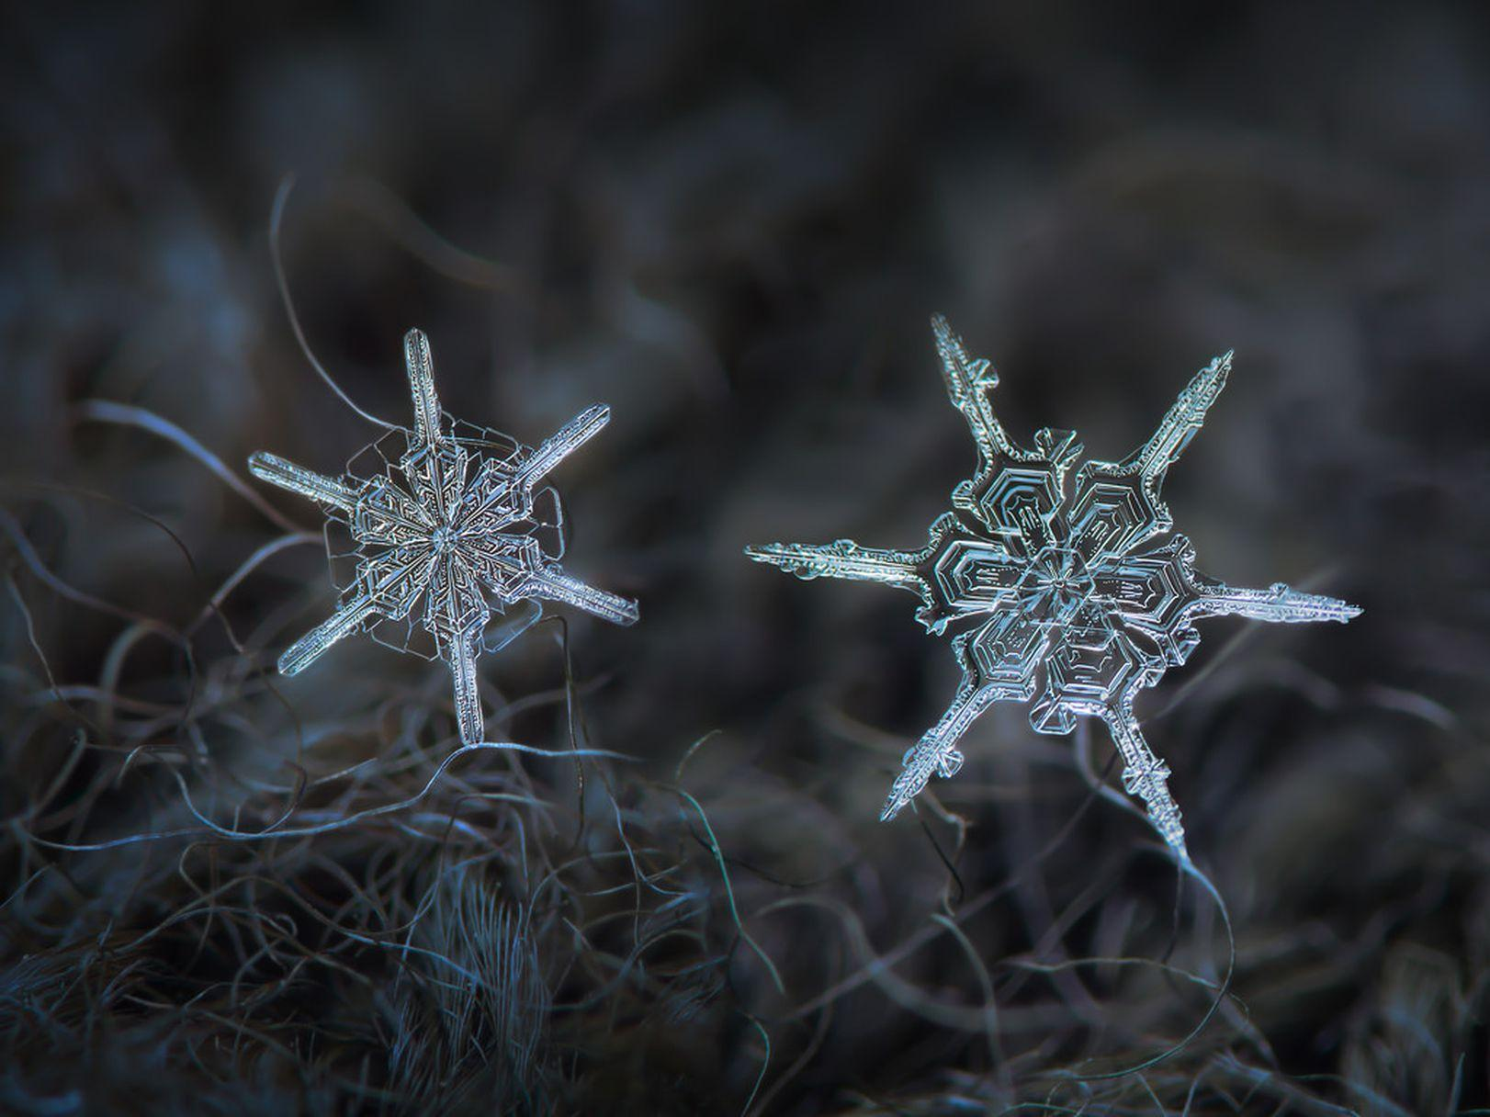
This composite image puts two snowflakes side-by-side. Photo by Alexey Kljatov on Flickr via CC 2.0
Snow can be soft and fluffy or stinging and icy; perfect for skiing or prone to melt. The difference lies in the shape of the flakes. They don’t all look like the kind you see in emoji.
Researchers have classified as many as 108 types, but according to Kenneth Libbrecht, a physicist at the California Institute of Technology, you can pare them down to four broad categories: plates, columns, needles, and dendrites.
By re-creating snowflakes in a lab, Libbrecht and other scientists found that the keys to getting one shape instead of another are temperature and humidity. Snow crystals form when the humidity is so high that the air can no longer hold water. Then vapor condenses into droplets, which begin to freeze. Higher humidity lets the crystals take on more complex shapes—when the air is drier, snowflakes grow more slowly and take on simpler forms.

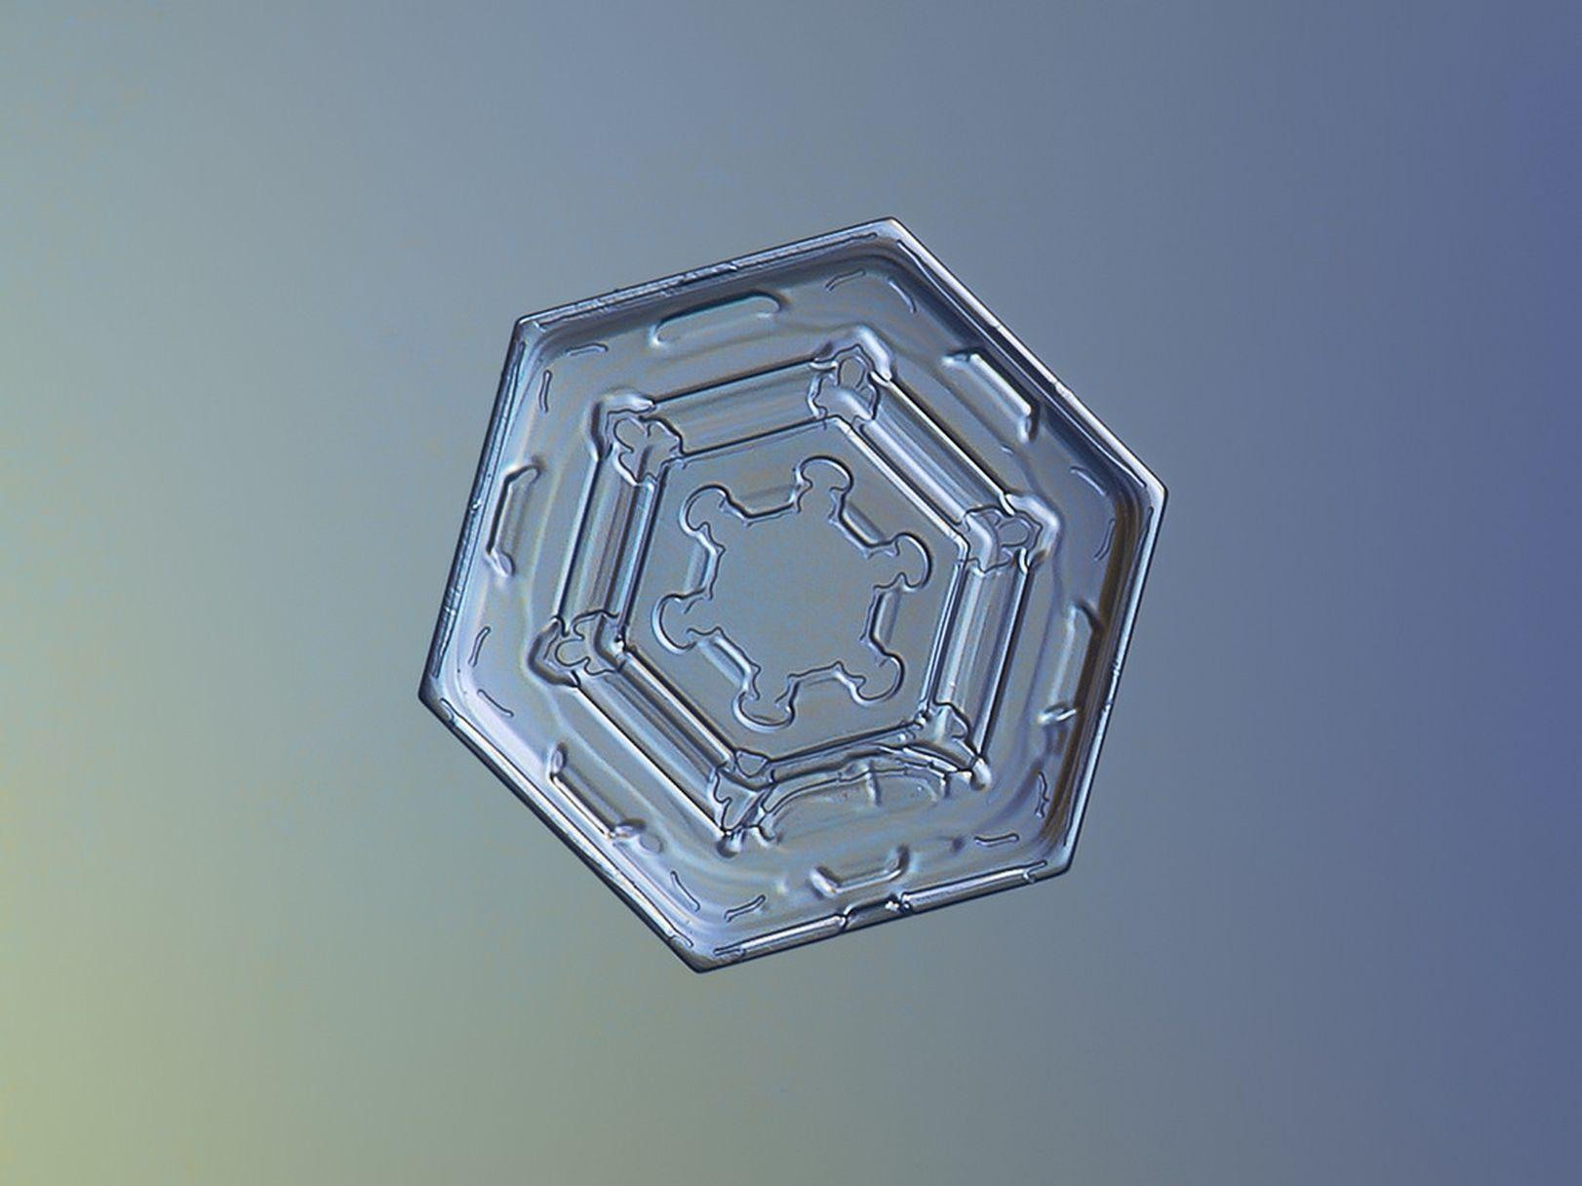
Plates
Alexey Kljatov on Flickr via CC 2.0
Light and flat, with six sides, plates are the one of the most common types of snowflake. Most snowfall contains a mix of small plates and other shapes. Libbrecht grows them in two sets of conditions: under 5°F or just below freezing.

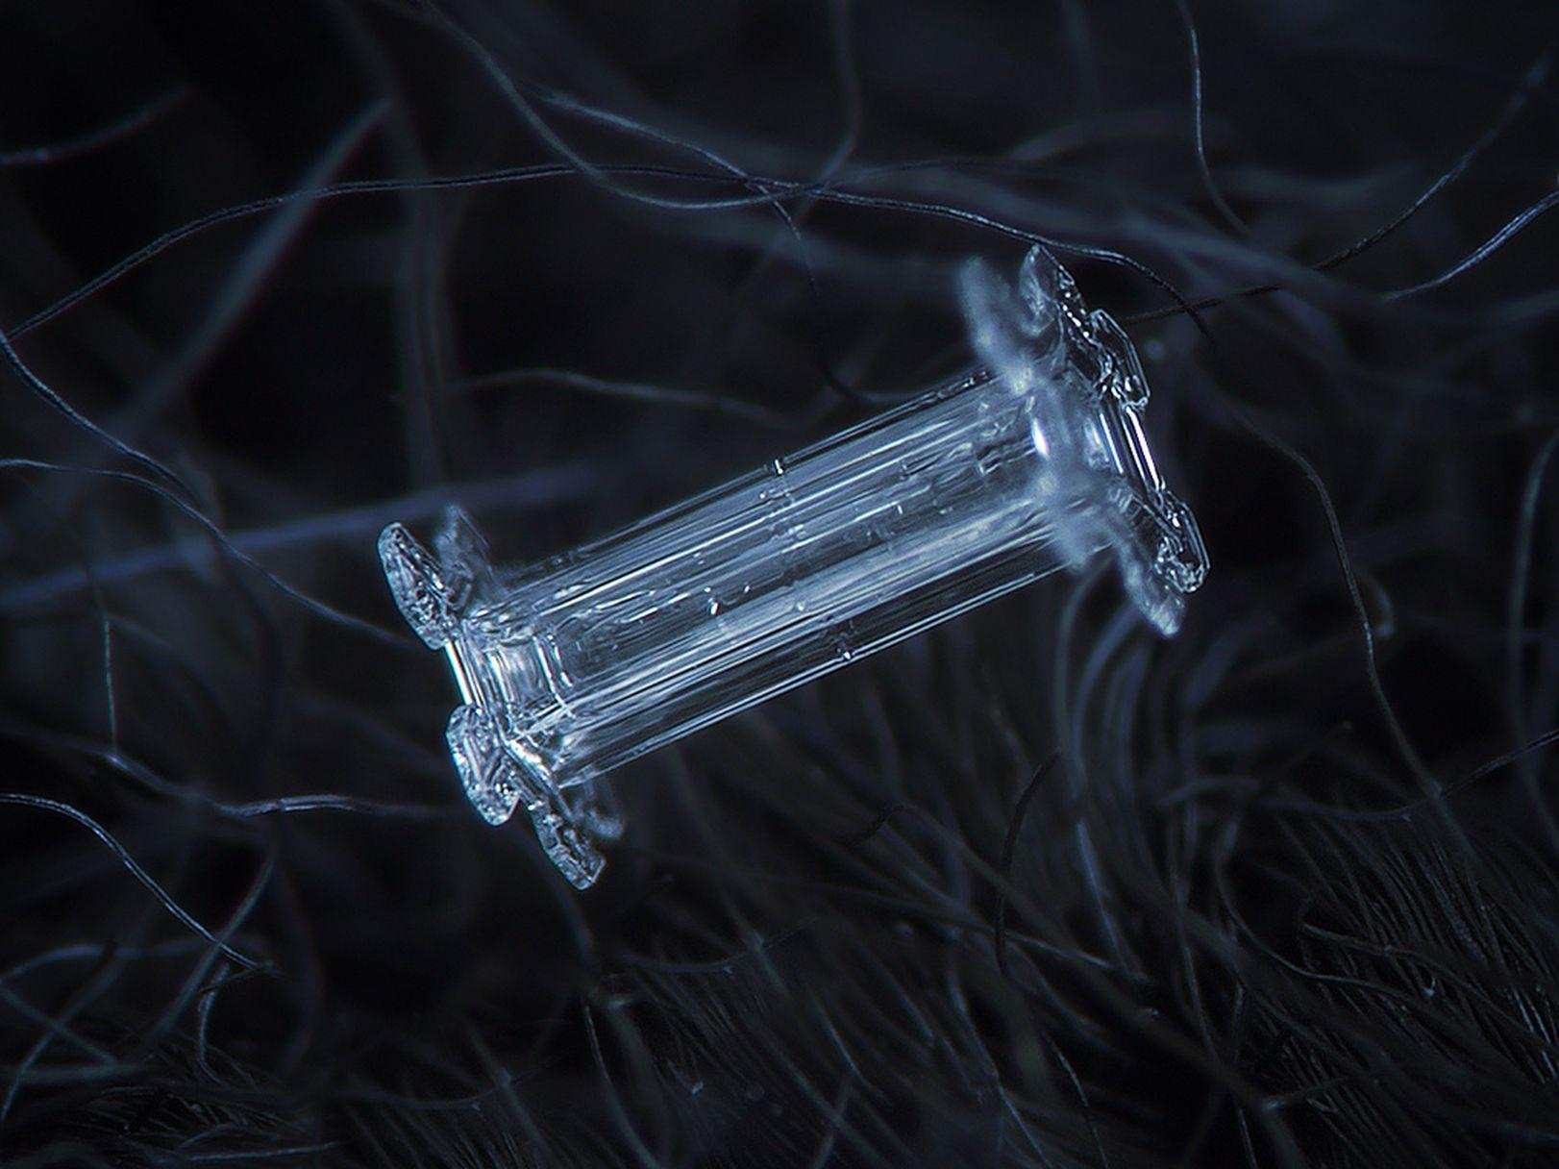
Columns
Alexey Kljatov on Flickr via CC 2.0
Column-like snowflakes look like white hair when they fall on your sleeve, but up close, you can see more delicate details. This type tends to form at very cold temperatures, which makes them less likely to stick together. You’re more apt to find them in a sand-like snowfall.

Needles
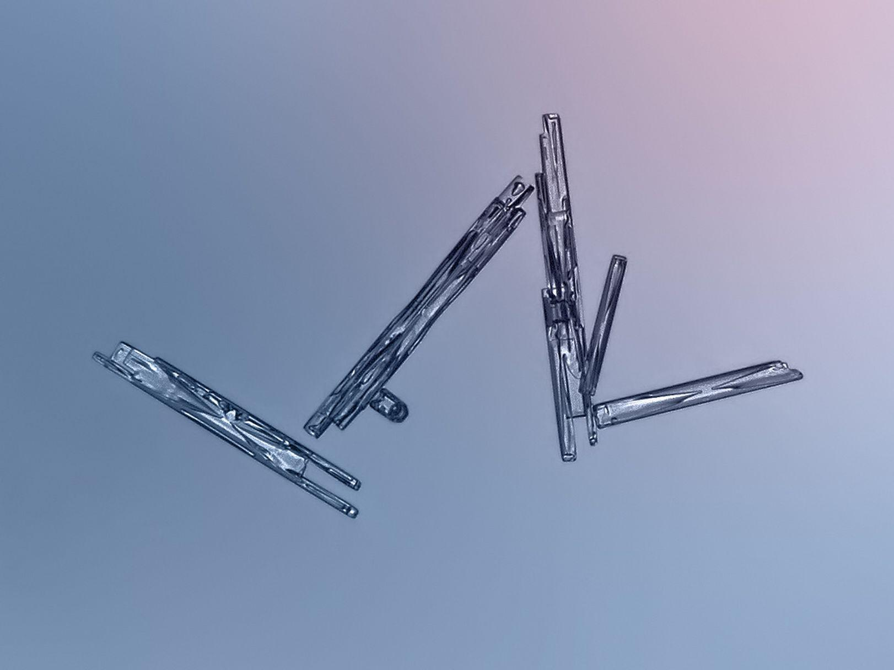
Alexey Kljatov on Flickr via CC 2.0
Despite their simple appearance, needle snowflakes actually boast a more complex structure than columns or plates. At mid-range humidity, they grow as fishbone-like branches, forming long, thin columns. This structure lets the flakes pack together very tightly, so when they hit the ground, they create a perfect blanket for downhill skiing or snowball-making.
Dendrites
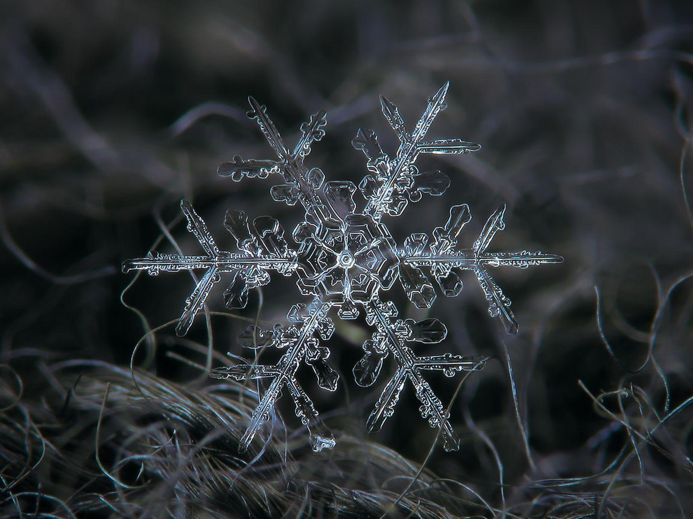
Alexey Kljatov on Flickr via CC 2.0
The secret ingredient for this intricate snowflake is relatively high humidity. With lots of moisture in the air, the vapor condenses more rapidly and the ice crystals branch more. Because dendrites have so many offshoots, they trap air in the snowpack, producing the fluffiest snow.
This article is a web exclusive for the July-August 2017 issue of Popular Science.

Snow science: Silent snow
What do you hear as snow falls? This winter phenomenon is the perfect opportunity to explore the science of sound.
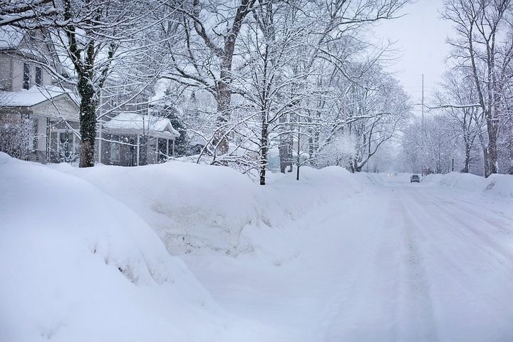
Melissa Elischer, Michigan State University Extension - December 21, 2016
What you probably noticed during or after a fresh snowfall is how quiet the world seems. Why does this happen? It’s because of the physical properties of snowflakes. In “Snow science: What is snow?,” we learn that snowflakes are solids. As a solid, this form of precipitation floats to the ground much slower than other forms of precipitation, such as rain. Rain falls faster and has a sound upon impact with the ground or another surface, making it a much louder form of precipitation.
Unlike rain, snowflakes have open space in their six-sided crystalline structure. This open space acts as a sound buffer, helping to reduce noise. Sound travels in waves and needs to vibrate the molecules in the solids, liquids or gasses to be transmitted. Sounds also travel faster in warmer conditions, so air temperature helps to slow down or speed up the waves, changing what is heard. If there are objects in the way, sound can be dampened, reducing what is heard. Snowflakes do just that! As snow begins to melt and change shape, sounds change yet again.
When snow melts, the space in between each crystal is reduced as well as the buffering property, and the silence of a fresh snow goes away. In fact, as snow turns into ice, it can actually make sounds louder because it will reflect sound waves instead of absorbing them.

QUESTIONS:

- Are snowflakes considered a solid, a liquid, or a gas?

- Explain how snowflakes get their shapes?

- What are some basic properties of sound?

- What are some basic properties of snow?

- How does sound travel? Explain.

- Based on what you have learned today about snow, do you think you are ready to answer the phenomenon question, “Why is it so quiet after a deep snowfall?” Explain why or why not.

