Name:
Class Period:
Solid, Liquid, Gas and the Elements
Objective: Students will investigate elements in order to determine characteristics of the different states of matter: Solid, Liquid, and Gas
Instructions:
Students go to www.periodictable.com and pick 20 different elements to investigate. Click on the element box to find out whether the element is found on earth as a gas, liquid, or a solid. Student will also record:
- the melting point and what the element becomes when melted
- the freezing point and what the element becomes when frozen
- the density
- where the element is found
- the characteristics of the element

EXAMPLE:
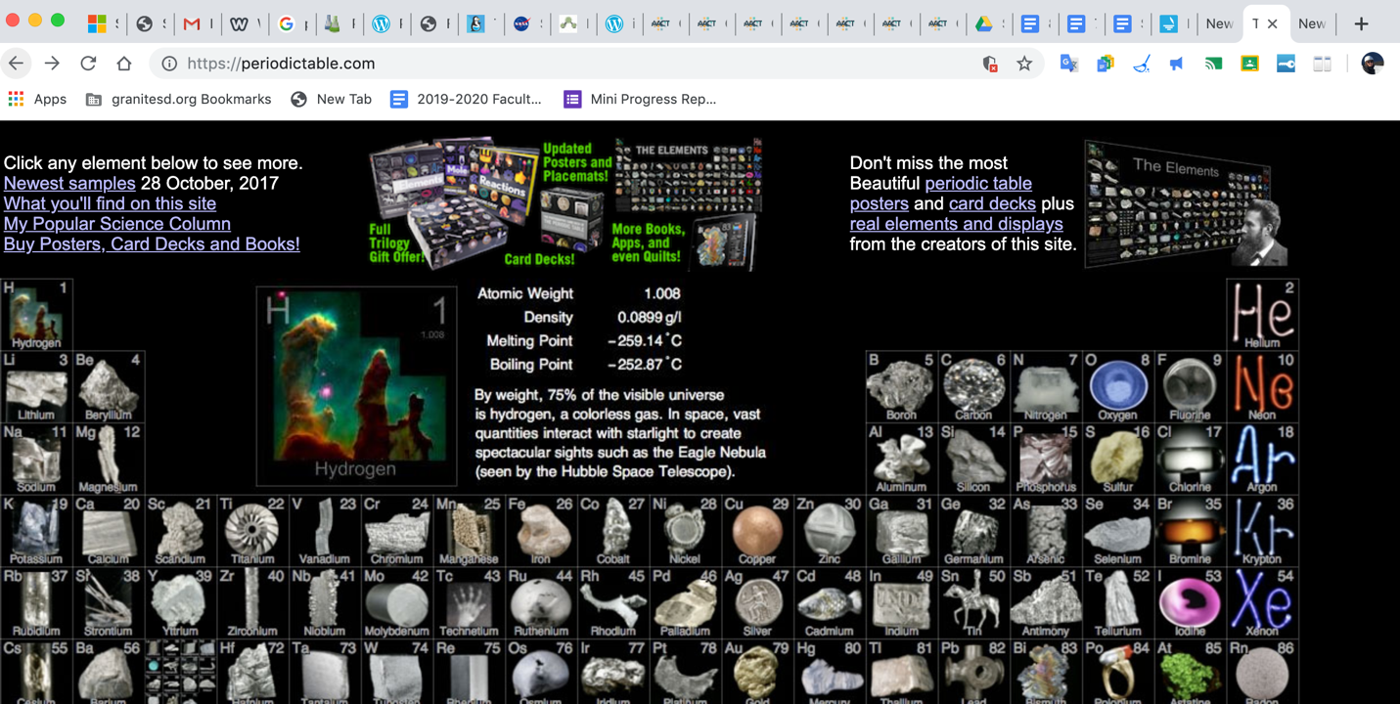

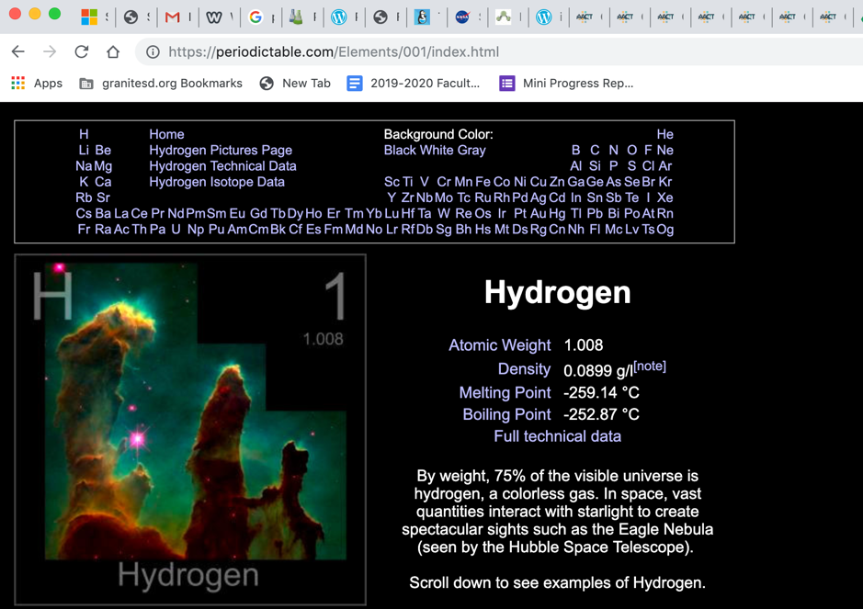
You will click on one of the element boxes. A bigger box will show up with information on that specific element.

You will record:
Name of Element: Hydrogen
State of Matter: Gas
Density: 0.899g/L
Melting point: -259.14°C
Boiling point: -252.87°C
Where is the element commonly found:
In the universe
Characteristics: Colorless, interacts with light

Name of Element | State of Matter  (Soild, Liquid, Gas) | Density  (g/L) | Melting Point  (°C) | Boiling Point  (°C) | Where is the element commonly found? | Charactistic #1 | Charactistic #2 | Charactistic #3

ANSWER THE FOLLOWING QUESTIONS:

1.Looking at your data table, what common characteristics did you find for solids?

2. Looking at your data table, what common characteristics did you find for liquids?

3. Looking at your data table, what common characteristics did you find for gases?

4. What do you think will happen to the solid elements when it reaches its melting point?

5. What do you think will happen to the solid element when it reaches its boiling point?

6. What did you notice about the densities of solids in comparison to the densities of liquids?
7. What did you notice about the densities of liquids in comparison to the densities of gases?

8. What did you notice about the densities of solids in comparison to the densities of gases?

9. Where were most soild elements found?

10. Where were most liquid elements found?

11. Where were most gas elements found?

12. What was the most interesting element that you learned about, and why?

