Name:
Class Period:

INTRODUCTION TO ATOMS AND THE PERIODIC TABLE

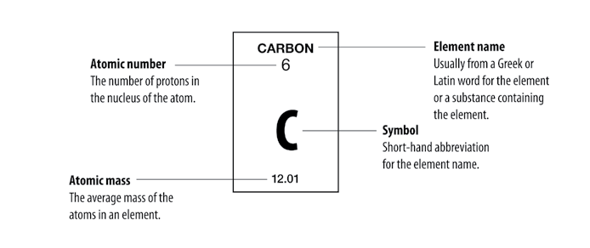

Parts of an Atom

Proton
Positively charged particle in the nucleus of the atom.
The number of protons in an atom’s nucleus is the atomic number.

Electron
Negatively charged particle surrounding the nucleus of the atom.
The number of electrons surrounding the nucleus of an atom is equal to the number of protons in the atom’s nucleus.

Neutron
Particle in the nucleus that has about the same mass as a proton but has
no charge. For the atoms of the first 20 elements, the number of neutrons is either equal to or slightly greater than the number of protons.

