PROCEDURE
To make a pendulum:
Tie a metal washer to the end of a 50-cm piece of string.
Hold the pendulum at the non-washer end. Ask your partner to give the pendulum energy by moving the washer about 30 cm to the right or left.
Have your helper let go of the washer so it can swing.
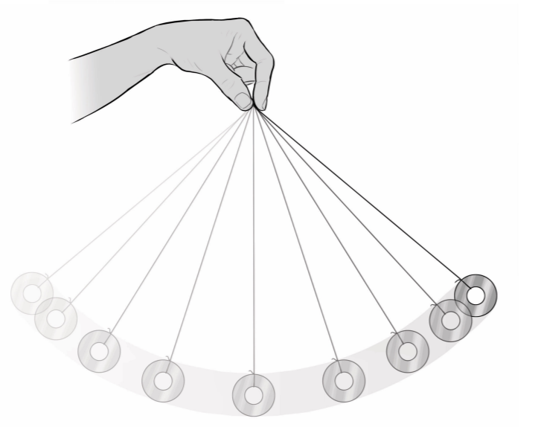

DATA
Where is the energy the greatest?

Where is the energy the least?

At what point does the energy change? Describe how it goes from greatest to least:

What happens if you just let the pendulum swing for a while?

What happened to the energy?

Label the sections below with one of the following… SOME WILL be used more than once!
At Rest
Slow
Fast
Fastest
