Photosynthesis Lab

Name:

STUDENT LEARNING OBJECTIVE:
Students will demonstrate the process of photosynthesis

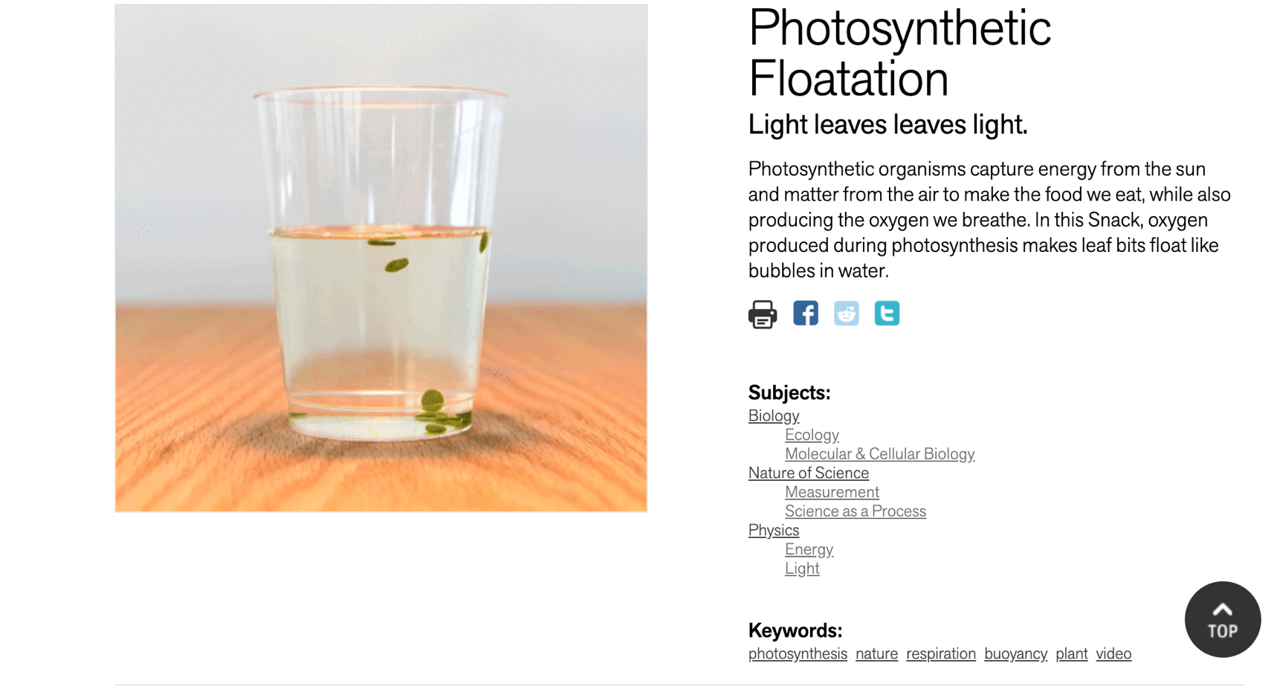

AFTER THE LAB:

Write the definition of:

Photosynthesis:

Buoyancy:

Cellular Respiration:

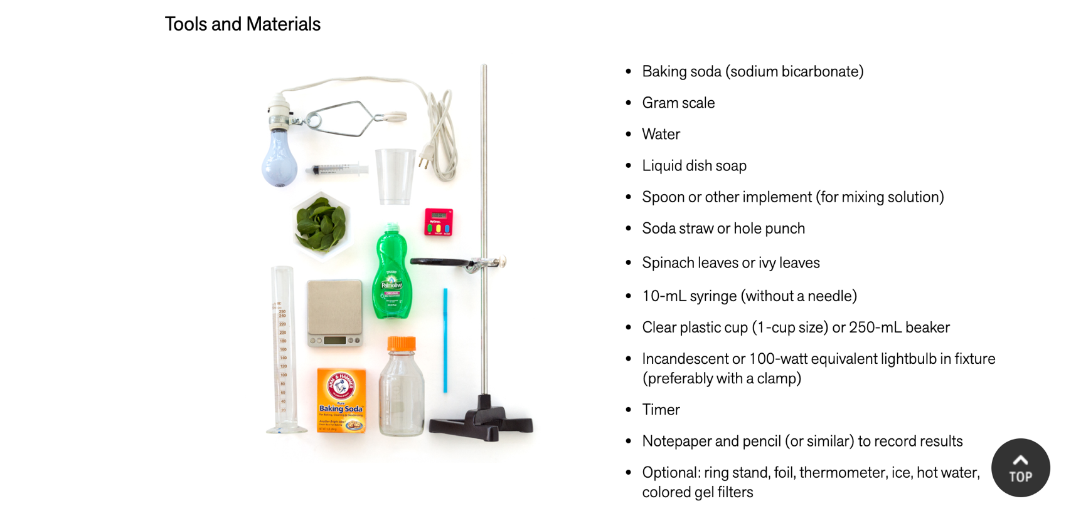

INSTRUCTIONS:
- Dissolve one gram (use scale to measure) of baking soda into 100 mL of distilled water.
- Hole punch the spinach leaves until you have about 20 circles of spinach.
- Pull the stopper out of the syringe and put in your spinach circles.
- Put the stopper back into the syringe – push it in toward the spinach WITHOUT SMASHING the spinach.
- Add about 5mL of baking soda solution to the syringe, and slowly push the stopper toward the spinach circles to get rid of the air in the syringe.
- Put your thumb over the syringe to create a vacuum, pull the stopper down and slowly back up – the spinach circles should begin to float in the solution once you have the air out of the spinach.
- Pull the stopper out and put the contents of the syringe into the beaker with the rest of the baking soda solution.
- Add bowl of water on top of the beaker, put under the lamp. START THE TIMER.
- Watch the solution until you start to see bubbles forming around the spinach circles. Write down how long it took.

QUESTIONS:

What are some ways we could take this lab to the next level of understanding – what variables could we test?

