Name: Date:
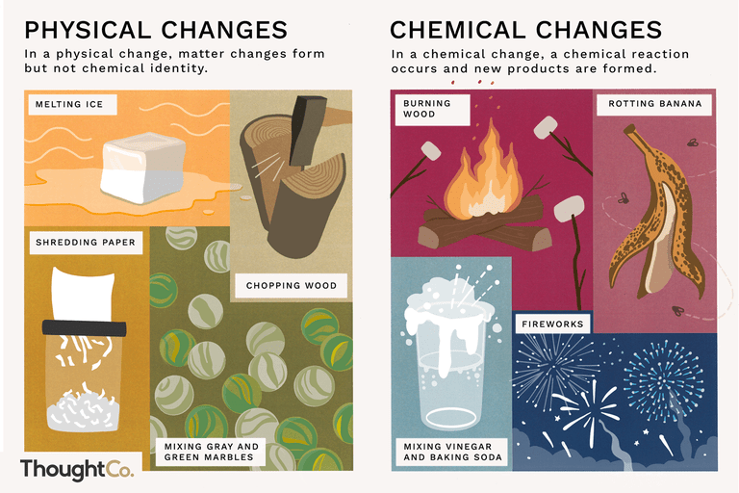
Physical and Chemical Changes Lab

READ BEFORE YOU START YOUR LAB – READ WITH YOUR TEAM MEMBERS

States of Matter – States of matter have to do with what state the matter is in, such as a solid, a liquid, or a gas.

Physical changes are usually about physical states of matter. A physical change is a type of change in which the form of matter is altered but one substance is not transformed into another. The size or shape of matter may be changed, but no chemical reaction occurs. Physical changes are usually reversible.

A chemical change occurs when a new substance is formed through a chemical reaction. Chemical changes happen on a molecular level when you have two or more molecules that interact. Chemical changes happen when atomic bonds are broken or created during chemical reactions.
When chemical reactions occur, the atoms are rearranged and the reaction is accompanied by an energy change as new products are generated.
These processes are called chemical reactions and, in general, are not reversible except by further chemical reactions. Some reactions produce heat and are called exothermic reactions and others may require heat to enable the reaction to occur, which are called endothermic reactions. Understanding chemical changes is a major part of the science of chemistry.

Experiment A – Complete this discussion question with your team AFTER completing Experiment A
Discussion Question - A doctor might tell someone to use an antacid if their stomach produces too much acid. Based on what you observed, how do you think antacids work?

District Lab: Physical and Chemical Changes

Content Objective: Students will differentiate between chemical and physical changes by conducting a series of experiments.

Materials:

- Safety goggles
- Graduated cylinders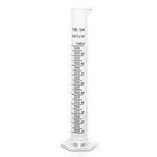
- Small plastic cups
- Small plastic jars
- Ice
- Antacid tablets
- Baking soda
- Lemon juice
- Vinegar
- Milk
- Kool-Aid powder

Purpose:
Upon completion, the learner will be able to differentiate between physical and chemical changes. Physical changes occur when objects undergo a change that does not change their chemical nature. A physical change involves a change in physical properties. Physical properties can be observed without changing the type of matter. Examples of physical properties include: texture, shape, size, color, odor, volume, mass, weight, pH and density. Chemical changes are changes substances undergo when they become new or different substances. For example, the fireworks we see on the 4th of July are actually metals such as magnesium and copper that change chemically as they light up the night skies with their fantastic colors. To identify a chemical change look for observable signs such as color change, bubbling and fizzing, light production, smoke, and presence of heat.

Physical and Chemical Change Experiments

Directions: Record all observations on the investigation table. Talk about the “Discussion Question(s)” with your group.

Experiment A: Antacid tablet
- Observe and describe the antacid tablet at your table.
- Break the tablet into small pieces.
  - Is this a physical or chemical change?
- Using a graduated cylinder, measure 50 ml of water and add it to a cup. Drop the tablet pieces into the cup.
- Observe what happens.
  - Is this a physical or chemical change?
- When you are finished, empty the cup, rinse the cup with water and save the cup for experiment B.

Discussion Question - A doctor might tell someone to use an antacid if their stomach produces too much acid. Based on what you observed, how do you think antacids work?

Experiment B: Ice
- In the empty cleaned cup from experiment A, place 1 ice cube in the cup.
- Observe and record how the ice looks and feels.
- Set the cup and ice cube aside until you are finished with the other experiments.

Experiment C: Baking soda and lemon juice
- With a graduated cylinder, measure 40 ml of lemon juice and add it to a larger container. Rinse the graduated cylinder.
- Add 1 teaspoon of baking soda to the lemon juice in the larger container.
- Observe and record the changes.
  - Is this a physical or chemical change?
- Empty the container, rinse it, and save it for experiment E.

Experiment D: Play-doh
- Remove the Play-doh from its container and describe how it looks, feels, and smells.
- Break the Play-doh up into many small pieces.
- Observe and record the change.
  - Is this a physical or chemical change?

Experiment E: Baking soda and vinegar
- Add 1 teaspoon of baking soda to the cleaned container from Experiment C
- Using the graduated cylinder, measure 10 ml of vinegar. Add the vinegar to the baking soda container.
- Observe and record the change.
  - Is this a physical or chemical change?
- Empty the container, rinse the container and graduated cylinder and save them for experiment F.

Experiment F: milk and vinegar
- Using the graduated cylinder, measure 50 ml of milk and add it to the container saved from experiment F.
- Using the graduated cylinder, measure 30 ml of vinegar and add it to the same container.
- Observe and record the change.
  - Is this a physical or chemical change?
- Rinse the equipment (graduated cylinder and container).

Experiment G: Kool-Aid and water
- Add 1 teaspoon of Kool-Aid powder to a jar.
- Using the graduated cylinder, add 60 ml of water to the same jar.
- Close the lid of the jar and gently mix by swirling it.
- Observe and record the change.
  - Is this a physical or chemical change?

Back to Experiment B: Ice
- Look at the cup that held the ice cube from experiment B.
- Observe and record the change.
  - Is this a physical or chemical change?

Experiment | Original  Substance(s) | Description  Before  Change  (Use at least 3 adjectives) | Description  During  Change | Description  After  Change  (Use at least 3 adjectives) | Is it a physical or chemical change?
A | Antacid  crushed
A | Antacid in Water
B | Ice
C | Baking Soda & Lemon Juice
D | Play-doh broken into bits
E | Baking Soda & Vinegar
F | Milk & Vinegar
G | Kool-aid & Water

1. The crushing of the antacid tablet was an example of:
A. Chemical Change
B. Physical Change
C. Neither a Physical or Chemical Change
D. Both a Physical and Chemical Change

2. If a substance changes color then what has occurred?
A. Physical Change
B. Chemical Change
C. Either a Physical or Chemical Change
D. Neither a Physical or Chemical Change

3. Which of the following is not an example of a physical change?
A. New substance is formed
B. Change in its state of matter
C. Change in volume
D. Change in texture

4. When gases are released from a reaction what type of change has occurred?
A. Physical
B. Chemical
C. Neither
D. Both

5. Which of the following is an example of a chemical reaction?
A. Ice melting
B. Paper being torn
C. Combining of vinegar and baking soda
D. Crushing of the antacid

6. In experiment F you combined 25 ml of milk with 30 ml of vinegar. After 10 minutes you observe the mixture again and the graduated cylinder now reads a total of 51.5 ml. How many ml have evaporated from the mixture?

