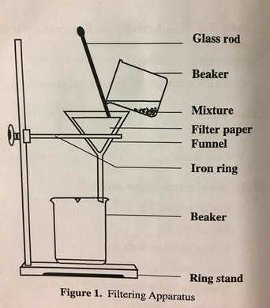
PHYSICAL CHANGE LAB

Name:
Period: Date:

OBJECTIVES:
- Students will learn that physical change can be reversed.
- Students will learn about the Conservation of Mass/Matter
SAFETY CONCERNS:
- Students will wear their lab coats and goggles throughout the entire experiment.
- Concerns for this lab are students getting substances in their eyes and on their clothing.
- Students should read through the SDS for Zinc, Iron Filings, Sand, and Sodium Chloride before starting the lab. SDSs for this lab are on the Student Labs page of our website under the instructions for this lab.
INSTRUCTIONS:
1. Decide who will do each job.
2. Reader should read through ALL OF THE LAB INSTRUCTIONS TO THE TEAM BEFORE STARTING THE LAB – THERE ARE NOT ENOUGH MATERIALS FOR STUDENTS TO HAVE MORE THAN ONE SET OF CHEMICALS.
3. Once everyone has heard and understood the instructions, send the Resource Manager over for the materials.

OBSERVATIONS – PreLab
1. Look at the chemicals that will be used in the lab. Describe each item in great detail – remember to smell we waft – we don’t whiff. Your observations should include looks, texture, color, etc. Once you’ve written out your observation, then draw a picture of each item.

SAND ZINC
OBSERVATIONS: OBSERVATIONS:

IRON FILINGS SODIUM CHLORIDE
OBSERVATIONS: OSBERVATIONS:

DATA TABLE 1.
Be sure to put the correct unit next to each of your measurements
Chemical | INITIAL MASS | INITIAL DENSITY | INITIAL  VOLUME | MAGNETIC YES/NO | ENDING MASS | ENDING DENSITY | ENDING VOLUME
Sand
Sodium Chloride
Iron Filings
Zinc

MASS OF ALL ITEMS WHEN MIXED DRY TOGETHER:
Does the mass of all of the individual items add up to the mass of all of the items together? If yes, why? If no, why not?
MASS OF CONTAINERS:
Measure the mass of each container in case you forget to “Mass it out” before measuring the mass of the chemicals.

Paper Square for holding chemicals:

Filter Paper:

250 mL Beaker:

400 mL Beaker:

OBSERVATIONS OF MIXTURE:
Describe each item in great detail – remember
to smell we waft – we don’t whiff.
Your observations should include looks, texture,
color, etc.
Once you’ve written out your
observation, then draw a picture of the mixture.

QUESTIONS:
What did you conclude about the properties of iron filings?

Look at the SDS for Iron Filings, what did you learn? What is its melting point?

What did you conclude about the properties of zinc?

Look at the SDS for Zinc, what did you learn? What is its melting point?

What did you conclude about the properties of sand?

Look at the SDS for Sand, what did you learn? What is its melting point?

What did you conclude about the properties of sodium chloride?

Look at the SDS for Sodium Chloride, what did you learn? What is its melting point?

What did you learn about physical changes by doing this lab?
Was the ending mass the same for sand? If yes, explain, if no, explain.

Was the ending mass the same for zinc? If yes, explain, if no, explain.

Was the ending mass the same for the iron filings? If yes, explain, if no explain.

Was the ending mass the same for the sodium chloride? If yes, explain. If no, explain.

What did you learn about solids from doing this lab?

What did you learn about liquids from doing this lab?

What did you learn about gases from doing this lab?

What did you learn about the effect of temperature on a state of matter?

What did you learn about the Law of Conservation of Mass/Matter by doing this lab?

How do you think this lab applies to our Phenomenon Question: “Is Jello a Solid or Liquid and Can it become a Gas?”

